**Praktikum 2 Sistem Basis Data 2023**

**NRP / Nama : 5025221161 / Mohammad Hanif Furqan Aufa Putra  
Kelas : J**

**RDBMS : MySQL**

**Link SQL :** [**https://drive.google.com/drive/folders/1qUy0KdCEFZFXwNeCTBZHrc0PeerZFt27?usp=drive_link**](https://drive.google.com/drive/folders/1qUy0KdCEFZFXwNeCTBZHrc0PeerZFt27?usp=drive_link)

**Kode Asdos : SBDJ02**

**Sesi : Modul Pendahuluan 3**

**Nomor 1**

Sintaks:

SELECT *

FROM transaksi

WHERE tanggal_transaksi BETWEEN '2023-10-10' AND '2023-10-20';

SELECT *

FROM transaksi;

Hasil:  
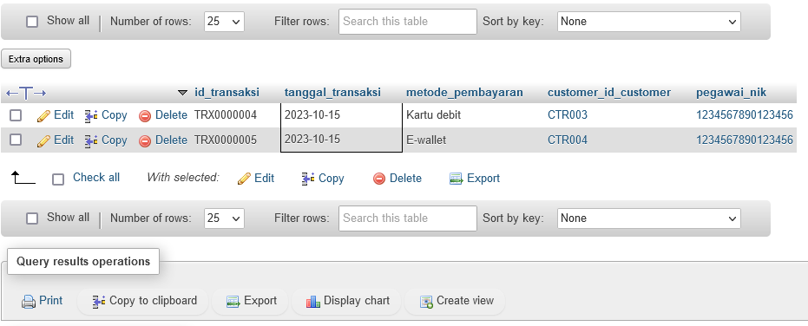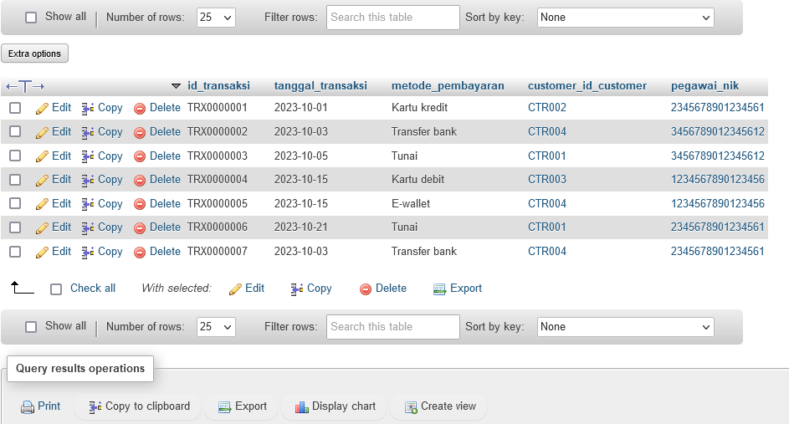

**Nomor 2**

Sintaks:

SELECT t.id_transaksi, SUM(mm.harga_minuman * tm.jumlah_minuman) AS TOTAL_HARGA

FROM transaksi t

JOIN transaksi_minuman tm ON t.id_transaksi = tm.tm_transaksi_id

JOIN menu_minuman mm ON tm.tm_menu_minuman_id = mm.id_minuman

GROUP BY t.id_transaksi;

Hasil:  
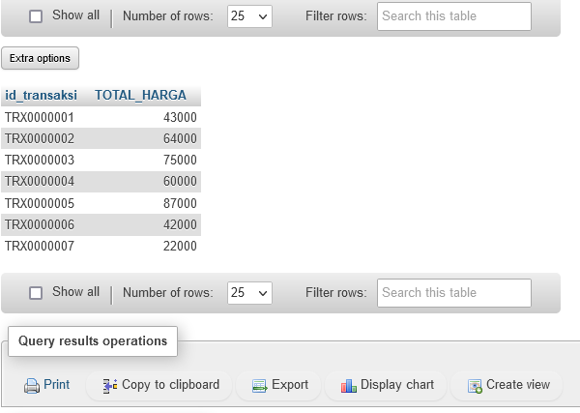

**Nomor 3**

Sintaks:

SELECT c.*, SUM(mm.harga_minuman * tm.jumlah_minuman) AS Total_Belanja

FROM customer c

JOIN transaksi t ON c.id_customer = t.customer_id_customer

JOIN transaksi_minuman tm ON t.id_transaksi = tm.tm_transaksi_id

JOIN menu_minuman mm ON tm.tm_menu_minuman_id = mm.id_minuman

WHERE t.tanggal_transaksi BETWEEN '2023-10-03' AND '2023-10-22'

GROUP BY c.id_customer

ORDER BY c.nama_customer;

Hasil: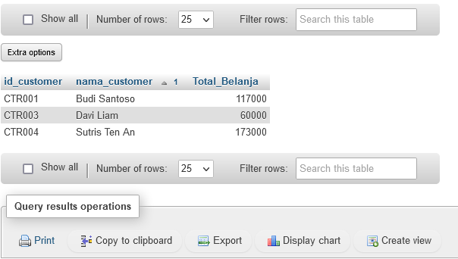

**Nomor 4**

Sintaks:

SELECT p.*

FROM pegawai p

JOIN transaksi t ON p.nik = t.pegawai_nik

JOIN customer c ON t.customer_id_customer = c.id_customer

WHERE c.nama_customer IN ('Davi Liam', 'Sisil Triana', 'Hendra Asto');

Hasil:

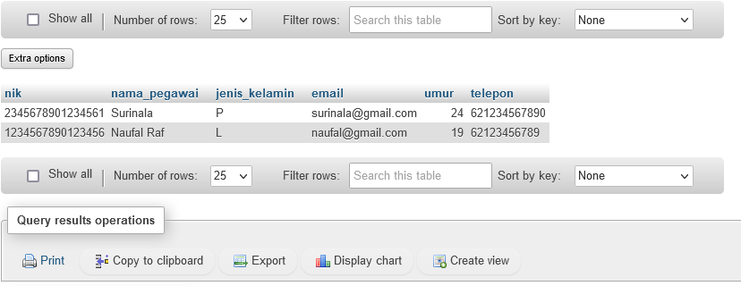

**Nomor 5**

Sintaks:

SELECT

EXTRACT(MONTH FROM t.tanggal_transaksi) AS BULAN,

EXTRACT(YEAR FROM t.tanggal_transaksi) AS TAHUN,

SUM(tm.jumlah_minuman) AS JUMLAH_CUP

FROM transaksi t

JOIN transaksi_minuman tm ON t.id_transaksi = tm.tm_transaksi_id

GROUP BY BULAN, TAHUN

ORDER BY TAHUN DESC, BULAN;

Hasil:

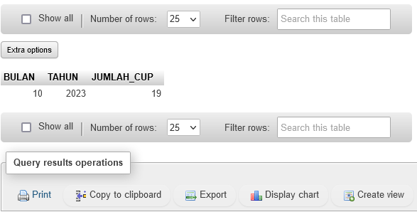

**Nomor 6**

Sintaks:

SELECT AVG(total_belanja) AS RataRata_Total_Belanja

FROM (

    SELECT t.id_transaksi, SUM(tm.jumlah_minuman * mm.harga_minuman) AS total_belanja

    FROM transaksi t

    JOIN transaksi_minuman tm ON t.id_transaksi = tm.tm_transaksi_id

    JOIN menu_minuman mm ON tm.tm_menu_minuman_id = mm.id_minuman

    GROUP BY t.id_transaksi

) AS subquery;

Hasil:  
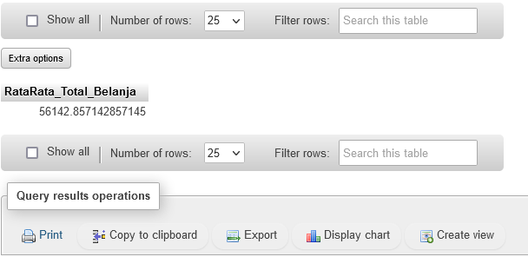

**Nomor 7**

Sintaks:

SELECT c.id_customer, c.nama_customer, AVG(t.total_harga) AS total_belanja

FROM customer c

JOIN (

    SELECT t.customer_id_customer, t.id_transaksi, SUM(tm.jumlah_minuman * mm.harga_minuman) AS total_harga

    FROM transaksi t

    JOIN transaksi_minuman tm ON t.id_transaksi = tm.tm_transaksi_id

    JOIN menu_minuman mm ON tm.tm_menu_minuman_id = mm.id_minuman

    GROUP BY t.customer_id_customer, t.id_transaksi

) t ON c.id_customer = t.customer_id_customer

GROUP BY c.id_customer, c.nama_customer

HAVING AVG(t.total_harga) > (

    SELECT AVG(total_harga)

    FROM (

        SELECT t.customer_id_customer, SUM(tm.jumlah_minuman * mm.harga_minuman) AS total_harga

        FROM transaksi t

        JOIN transaksi_minuman tm ON t.id_transaksi = tm.tm_transaksi_id

        JOIN menu_minuman mm ON tm.tm_menu_minuman_id = mm.id_minuman

        GROUP BY t.customer_id_customer, t.id_transaksi

    ) subquery

);

Hasil:

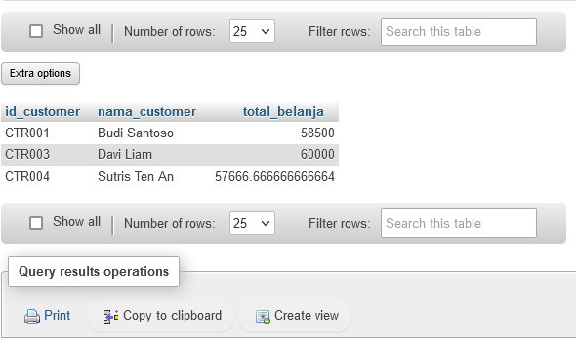

**Nomor 8**

Sintaks:

SELECT c.id_customer, c.nama_customer

FROM customer c

LEFT JOIN membership m ON c.id_customer = m.m_id_customer

WHERE m.m_id_customer IS NULL;

Hasil:

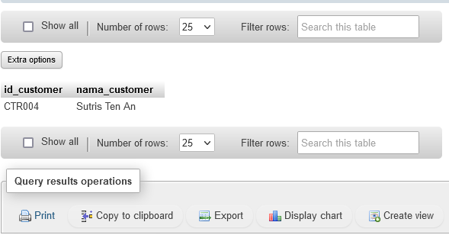

**Nomor 9**

Sintaks:

SELECT COUNT(DISTINCT t.customer_id_customer) AS Jumlah_Customer

FROM transaksi t

JOIN transaksi_minuman tm ON t.id_transaksi = tm.tm_transaksi_id

JOIN menu_minuman mm ON tm.tm_menu_minuman_id = mm.id_minuman

WHERE mm.nama_minuman = 'Latte';

Hasil:

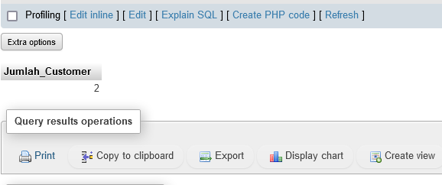

**Nomor 10**

Sintaks:

SELECT

    customer.nama_customer,

    menu_minuman.nama_minuman,

    SUM(transaksi_minuman.jumlah_minuman) AS total_cup

FROM customer

JOIN membership ON id_customer = m_id_customer

JOIN transaksi ON id_customer = customer_id_customer

JOIN transaksi_minuman ON id_transaksi = tm_transaksi_id

JOIN menu_minuman ON tm_menu_minuman_id = id_minuman

WHERE nama_customer LIKE 'S%'

GROUP BY

    nama_customer,

    nama_minuman;

Hasil: